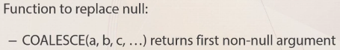

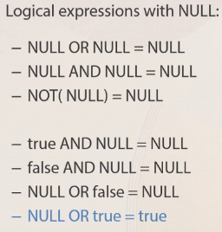

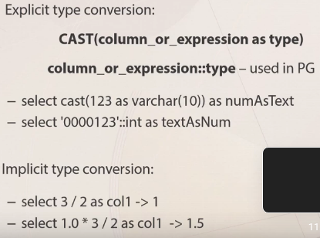

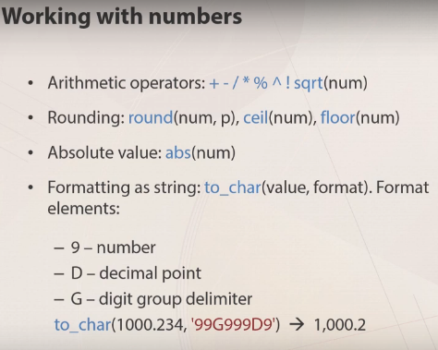

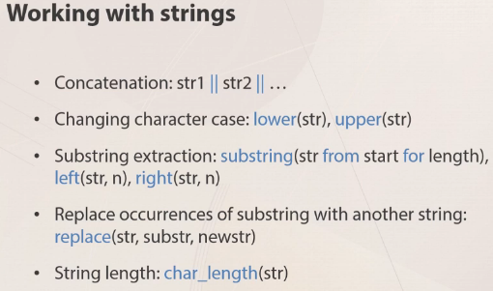

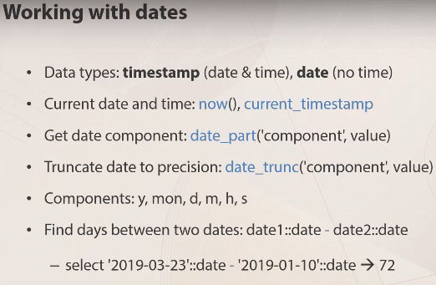

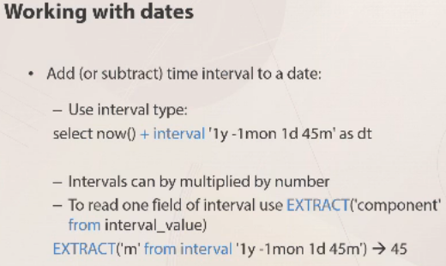

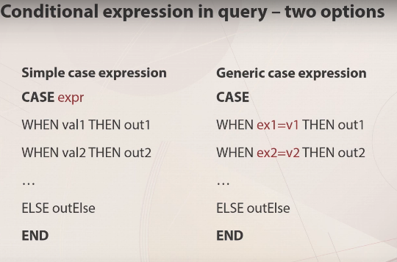

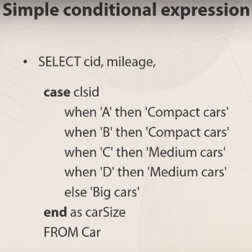
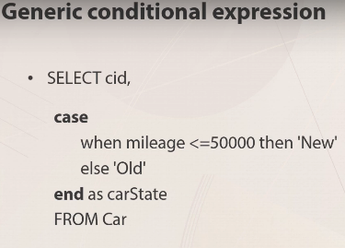

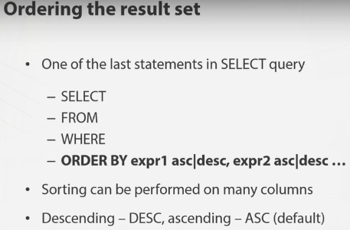

ascending — восходящий
descending - низходящий

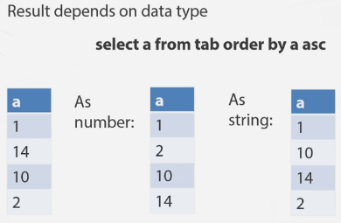

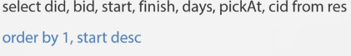

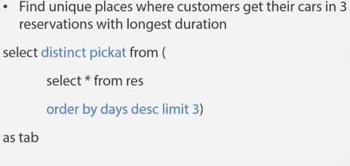

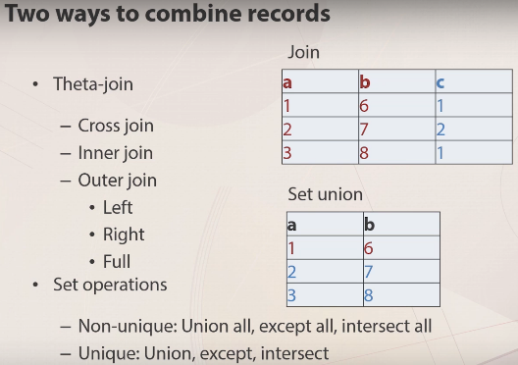

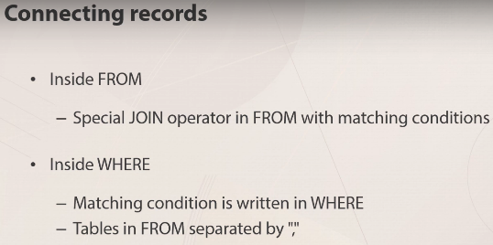

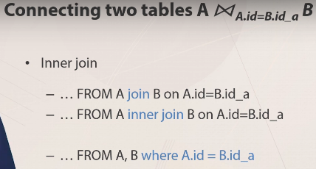

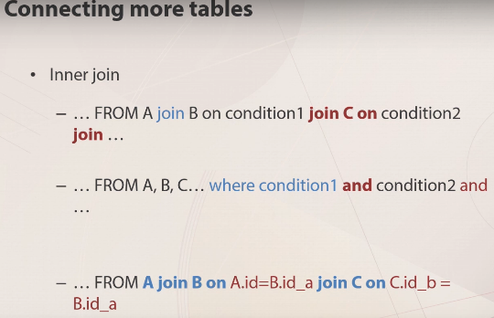

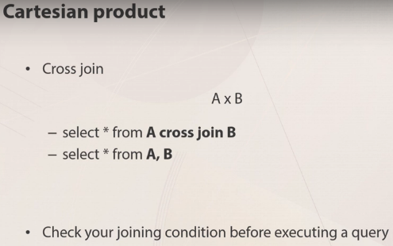

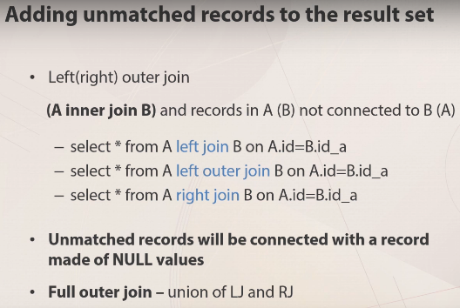

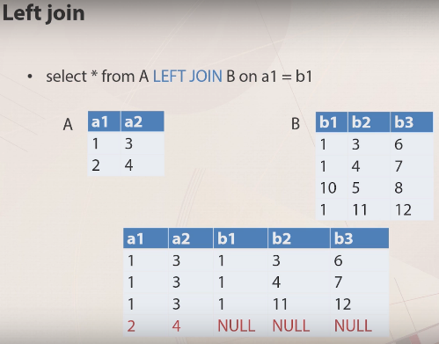

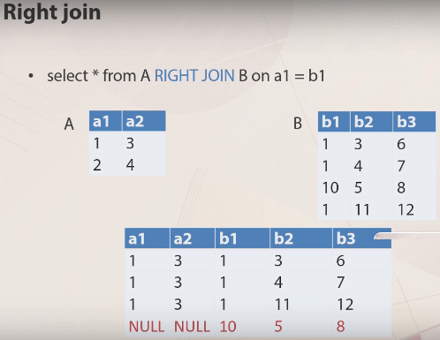

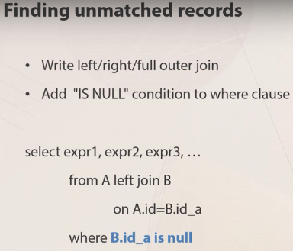

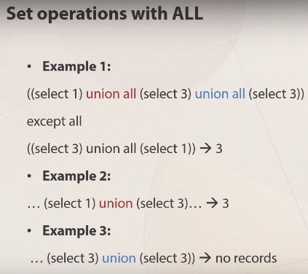

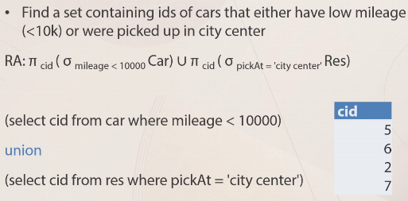

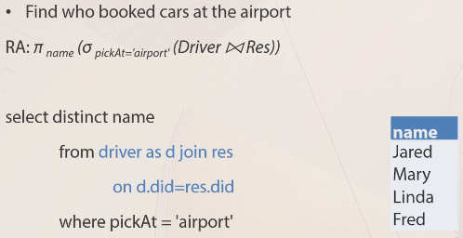

Примеры:
-------------------------------------------------------------------------------------------------------
Database contains 2 tables of regional managers:
managersUS (id, name, chief, city)
managersUK (id, name, chief, city)
The description for the columns is given below:
- id - unique manager's identifier
- name - manager's name
- chief - id of a managers's boss
- city - a city in which a manager works
Managers and their chiefs may work either in the same or in different regions. So the chief column can have values from the id field in one of the two tables.
Some managers do not have a chief. In this case, the chief field will be empty. One chief has one or more managers and can have a chief too.

1. Chiefs who have reporting managers only in their cities.

﻿select m.name as manager,
ch.name as chief
from managersUK m
join managersUK ch on m.chief = ch.id
where ch.city = m.city
union
select m.name as manager,
ch.name as chief
from managersUS m
join managersUS ch on m.chief = ch.id
where ch.city = m.city

2. Chiefs who have no chiefs.

select * from managersUK
where chief is null
union
select * from managersUS
where chief is null

3. Managers with chiefs from another region who also have their chiefs from the managers' region, e.g. a valid result here will be Ivan who works in the US, reports to Sophie from the UK, who reports to William from the US.

select * from managersUs m
join managersUK ch on m.chief = ch.id
join managersUS chch on ch.chief = chch.id
union
select *from managersUK m
join managersUs ch on m.chief = ch.id
join managersUK chch on ch.chief = chch.id

4. Managers with chiefs from another country.

select * from managersUK m join managersUS ch on m.chief = ch.id
union
select * from managersUS m join managersUK ch on m.chief = ch.id

-------------------------------------------------------------------------------------------------------

What official languages do people speak in countries with the capital's population exceeding 80% of the most populated city in the world?

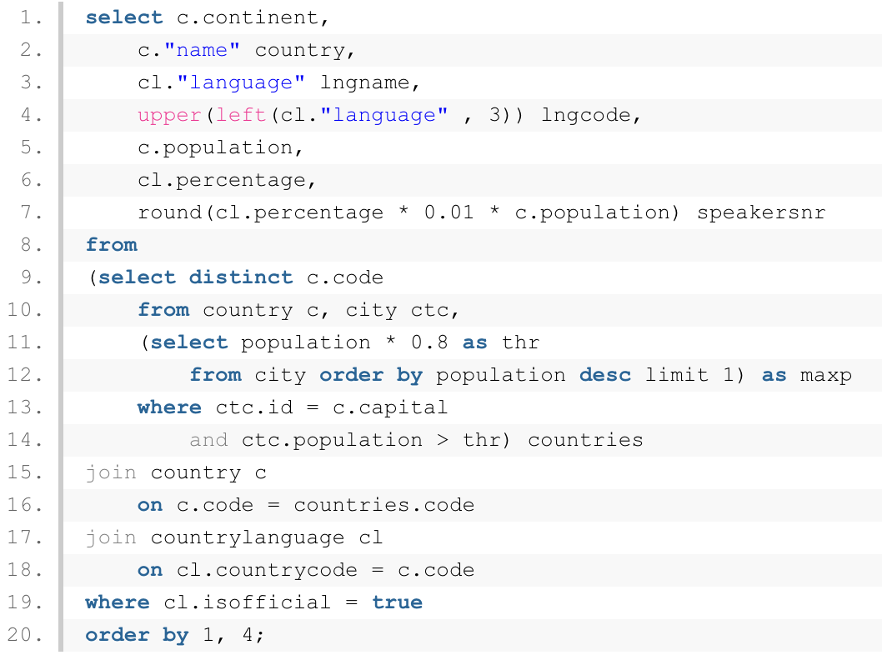

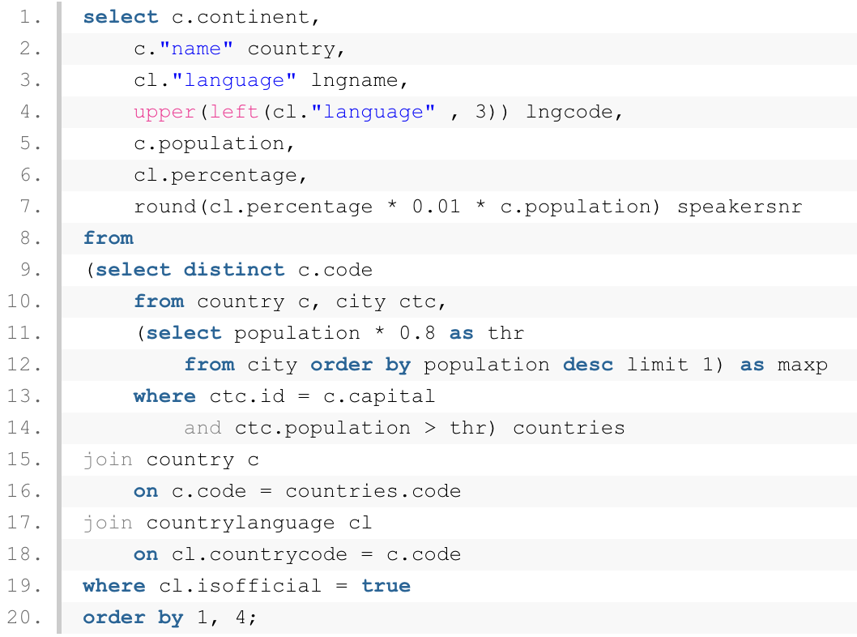
OR:

-------------------------------------------------------------------------------------------------------

Find a country with a gnp under 1% of the greatest GNP in the world. The records should be sorted by continent in alphabetical order and by gnp from greatest to lowest:
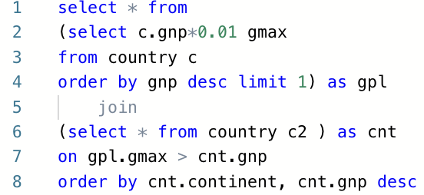

-------------------------------------------------------------------------------------------------------

Find out which non-capital city has the least population in North America?
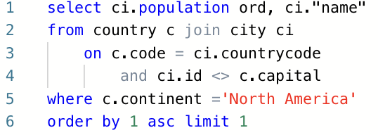

-------------------------------------------------------------------------------------------------------

What country has more than 4 words in its local name and has area per capita > 0.02?

select
code,
localname,
char_length(localname) as lng,
char_length(localname) - char_length(replace(localname, ' ', '')) + 1 as word_number,
surfacearea / population as PnN,
population,
surfacearea
from
country
where
(char_length(localname) - char_length(replace(localname, ' ', '')) + 1) > 4
and (surfacearea / population) > 0.02
and population > 0;
-------------------------------------------------------------------------------------------------------
This query was designed to return information about cities in North America and Africa with population share that equals at least 50% out of country's number of citizens. The population share in percent should be shown with two digits after period

select
name countryname,
name cityname,
to_char(100.0 * ct.population / c.population, '90D99') p_share
from country c
join city ct
on c.code = ct.countrycode
where
c.population > 0
and c.continent 'North America'
and c.continent = 'Africa'
and 1.0 * ct.population / c.population >= 0.5

-------------------------------------------------------------------------------------------------------

Non-correlated subqueries in WHERE

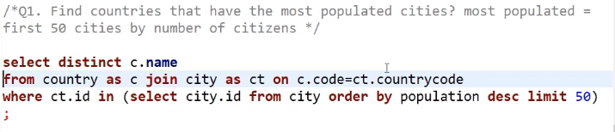
-------------------------------------------------------------------------------------------------------

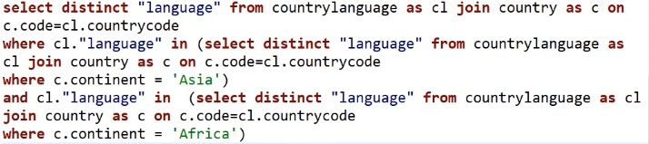
-------------------------------------------------------------------------------------------------------

Correlated subqueries in WHERE

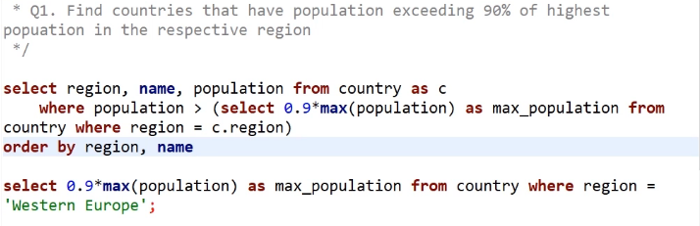
OR

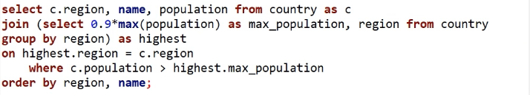
-------------------------------------------------------------------------------------------------------

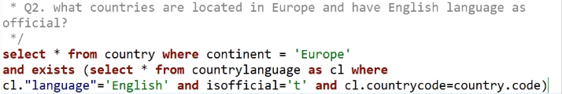
-------------------------------------------------------------------------------------------------------

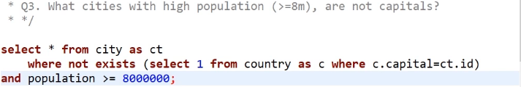

ALL and ANY in WHERE

-------------------------------------------------------------------------------------------------------

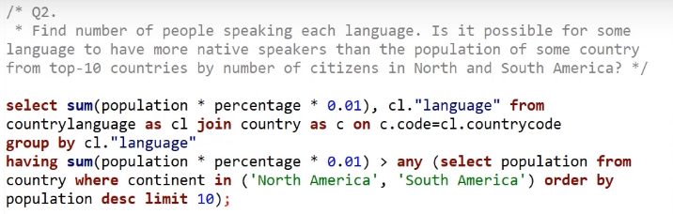
-------------------------------------------------------------------------------------------------------

Non-correlated subqueries in SELECT

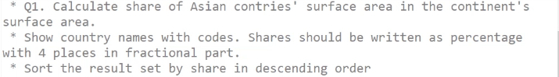
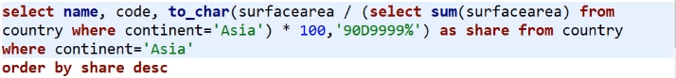
-------------------------------------------------------------------------------------------------------

Correlated subqueries in SELECT
Subquery should return only one or no result

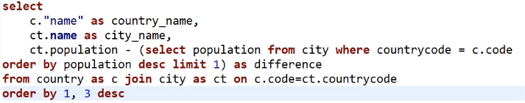
OR

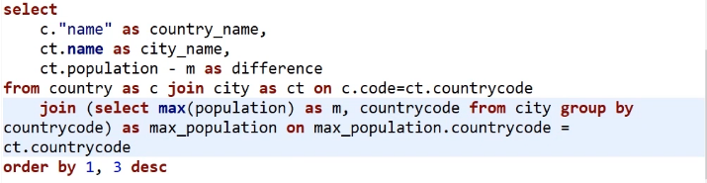
-------------------------------------------------------------------------------------------------------

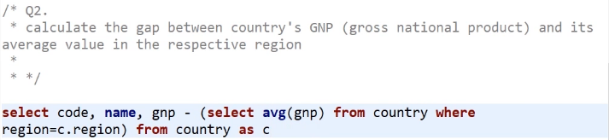

Other functions

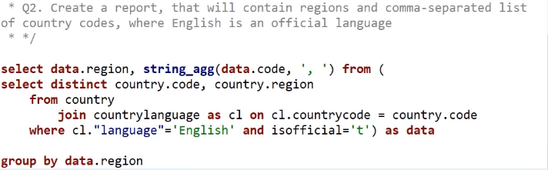
-------------------------------------------------------------------------------------------------------

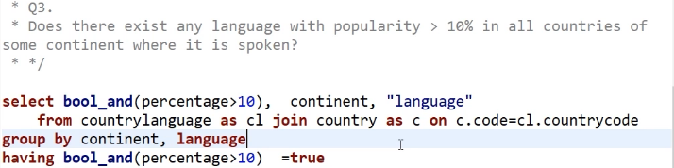

Создание базы данных на основе другой:
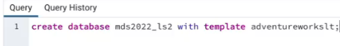

Создать индекс в таблице (нужен для быстрого поиска). В нашем примере поиск будет производиться быстрее, так как основан на методе бинарного поиска (btree). Создается по столбцу. Много индексов — не есть хорошо.

View

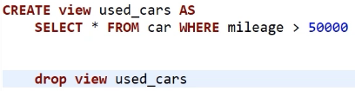

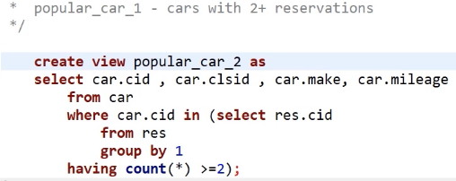

Views in a database

used_cars view - cars with mileage over 50k

CREATE view used_cars AS
SELECT * FROM car WHERE mileage > 50000

select * from used_cars

Remove a view
drop view used_cars

Read-only and updatable views
popular_car_1 - cars with 2+ reservations

create view popular_car_1 as
select car.cid , car.clsid , car.make, car.mileage
from car join res using (cid)
group by 1, 2, 3, 4
having count(*) >=2;

An updatable version of this view is shown below:

create view popular_car_2 as
select car.cid , car.clsid , car.make, car.mileage
from car
where car.cid in (select res.cid
from res
group by 1
having count(*) >=2);

Virtual PK in DBeaver for the editable view interface can be found on figure 1:

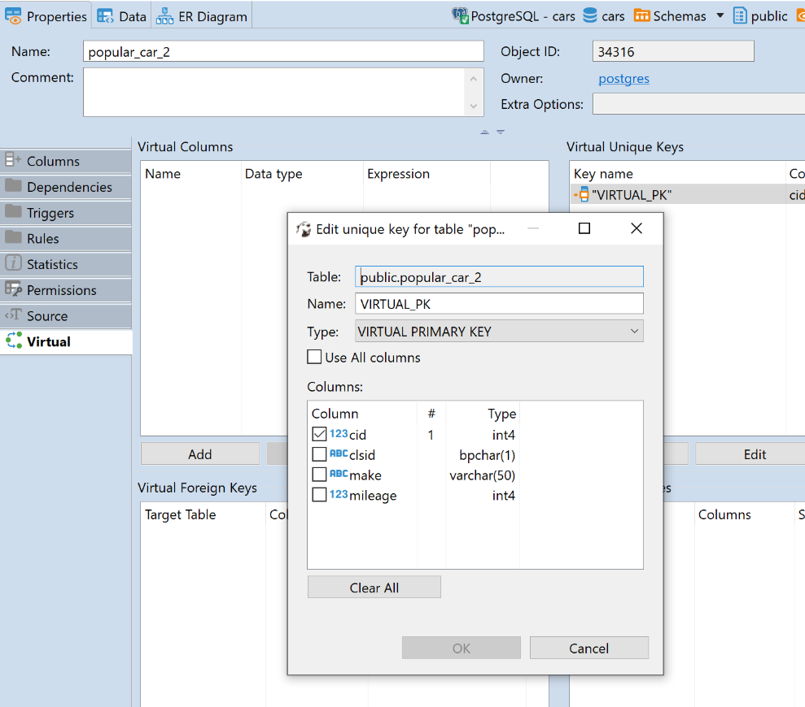

Materialized views
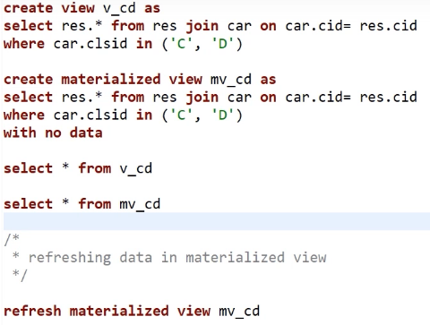

Window function

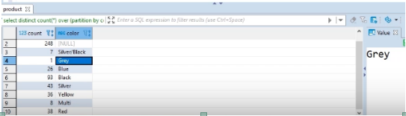

-------------------------------------------------------------------------------------------------------

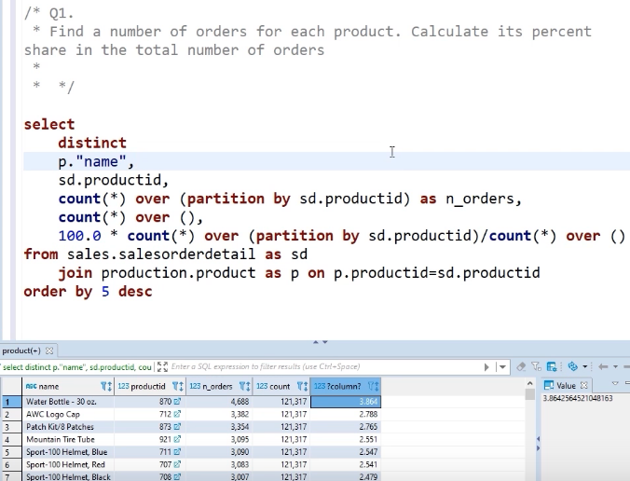
-------------------------------------------------------------------------------------------------------

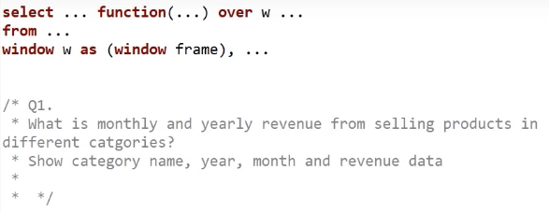

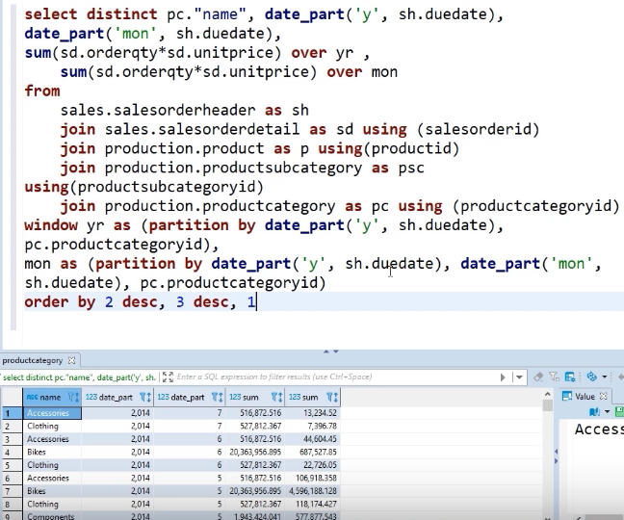
-------------------------------------------------------------------------------------------------------

Other Window function. Rank.

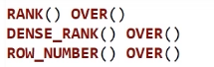

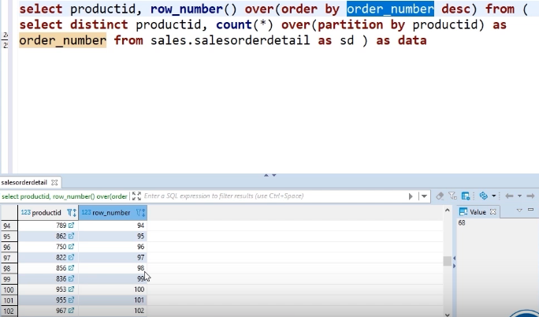
-------------------------------------------------------------------------------------------------------

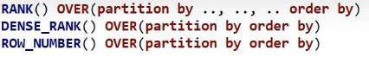

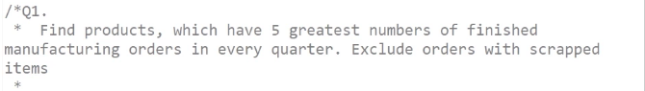
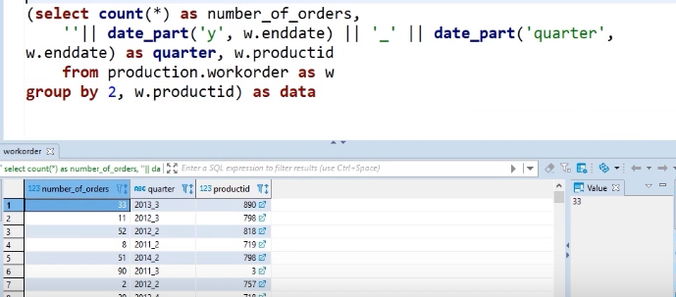
|
_|_
\ /
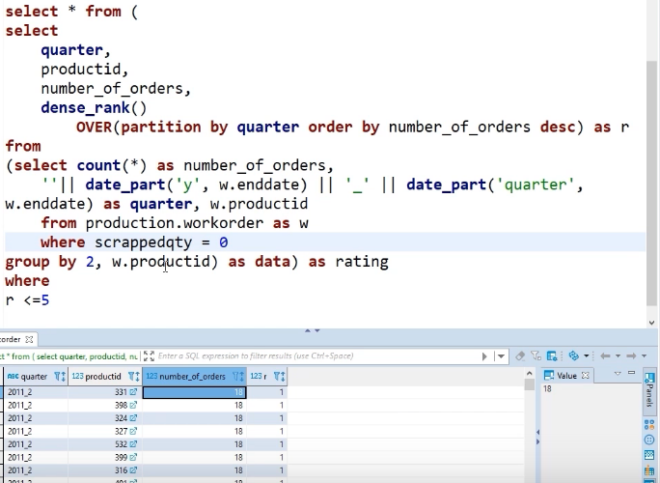
\/

Running totals

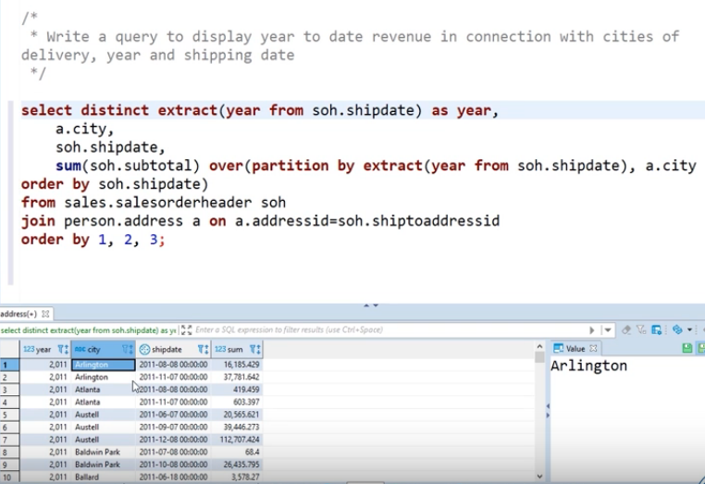

Accessing previous and next records

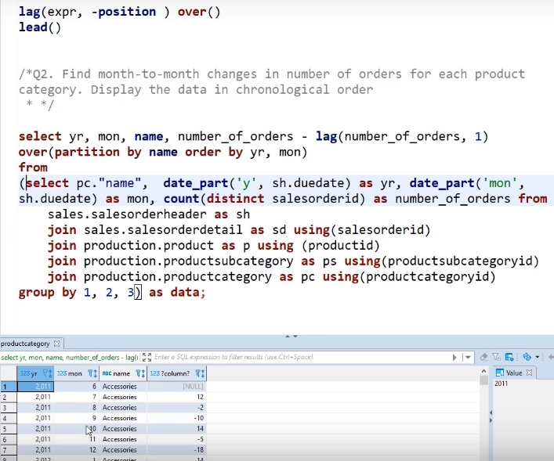
-------------------------------------------------------------------------------------------------------
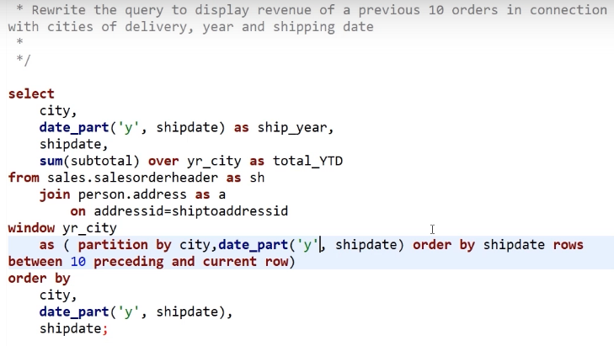

EXAMPLES

Write a query that will show aggregated subtotal and its moving averages with 5 and 20-day length and order date for 2013 in the individual customer segment (exclude orders made by companies).
You can distinguish companies from individuals by the non-empty companyname attribute.
Evaluate ma(20) and ma(5) on Feb 26, 2013

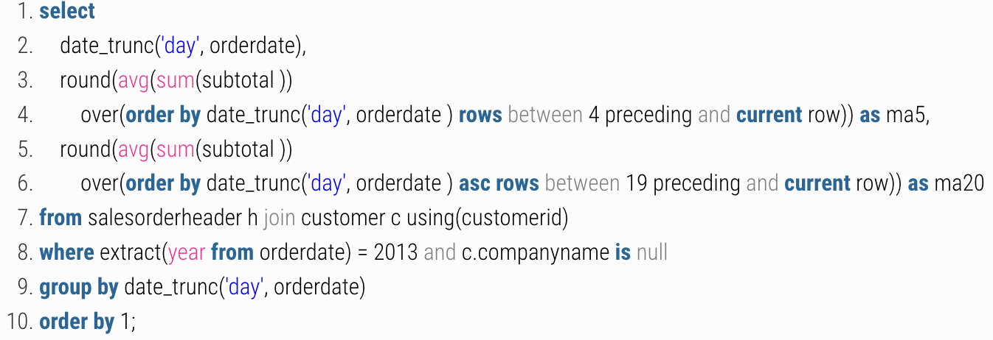
-------------------------------------------------------------------------------------------------------

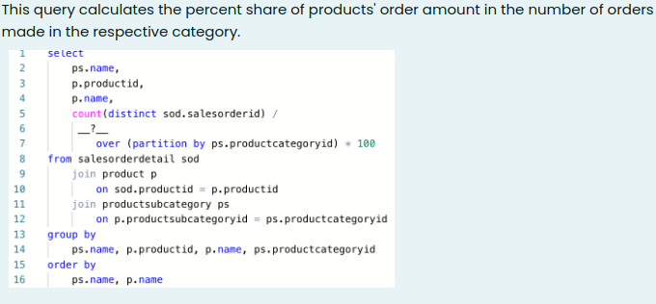
instead of __?__: sum( count( distinct sod.salesorderid ) )
-------------------------------------------------------------------------------------------------------

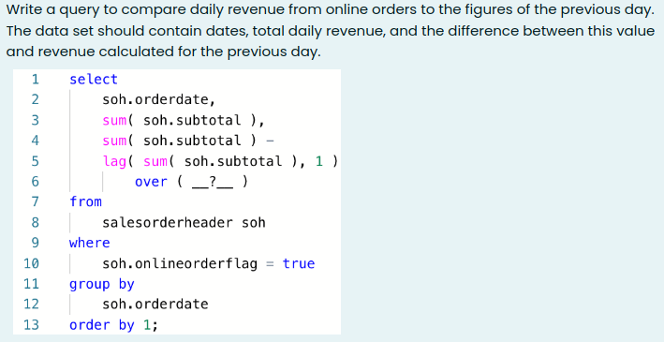
instead of __?__: order by soh.orderdate
-------------------------------------------------------------------------------------------------------
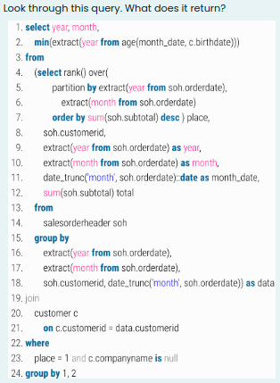

Age of the youngest individual customers who spent the most money on orders per month among all customers
-------------------------------------------------------------------------------------------------------

What is the difference between materialized and regular view?
Answer: A materialized view is a physical copy of its query's result. A regular view generates its contents when it is being called in a query
--------------------------------------------------------------------------------
/*The following query identifies the most popular products in each year based on its sales rates. */

select *
from
(select
extract('year' from h.duedate) as year, p."name" as productname, sum(d.linetotal) as total,
rank() over(partition by extract('year' from h.duedate) order by sum(d.linetotal) desc)
from
product as p
join salesorderdetail as d on p.productid = d.productid
join salesorderheader as h on h.salesorderid = d.salesorderid
group by
extract('year' from h.duedate), p.name
) as data
where
rank = 1

Data modifications with SQL

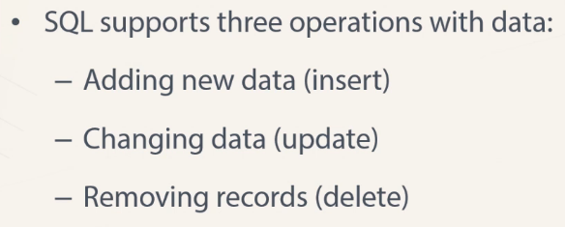

INSERT
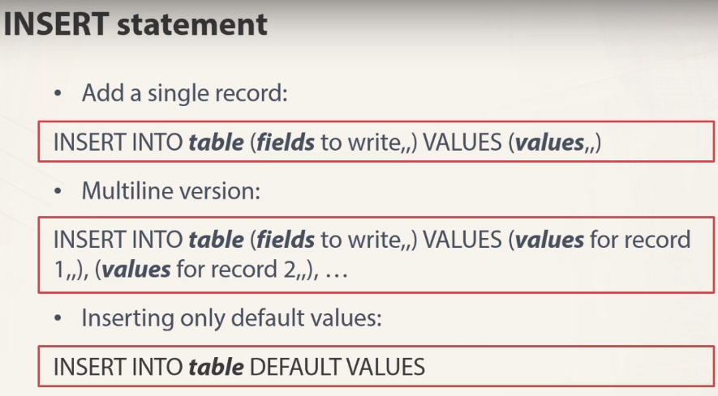

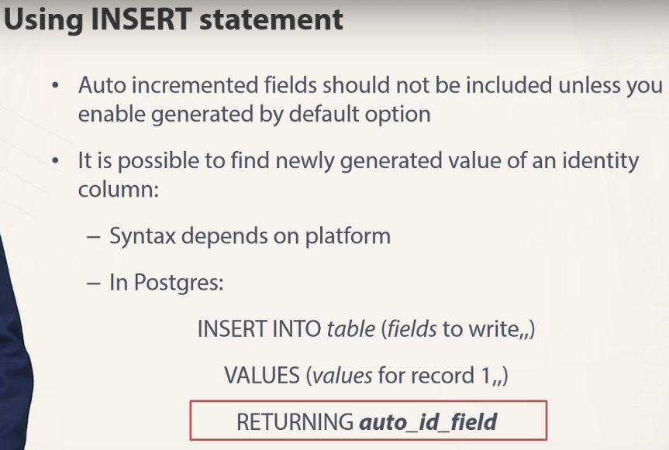
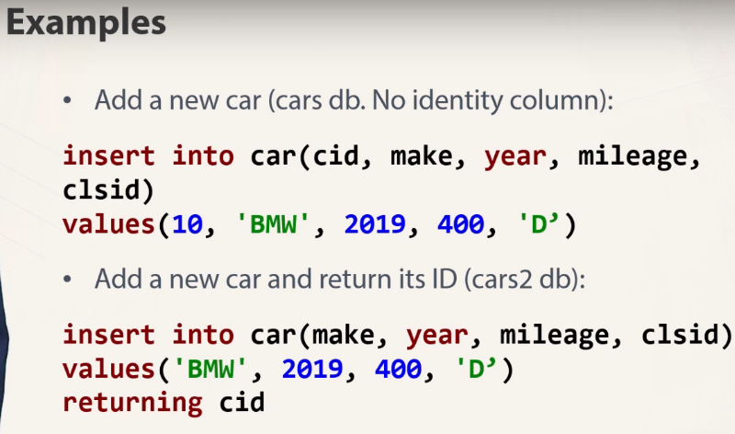

UPDATE
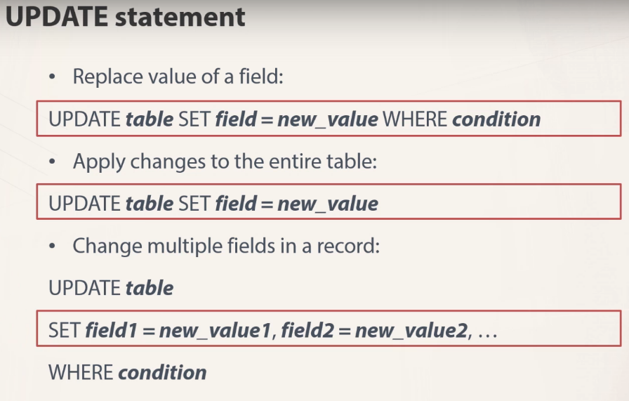
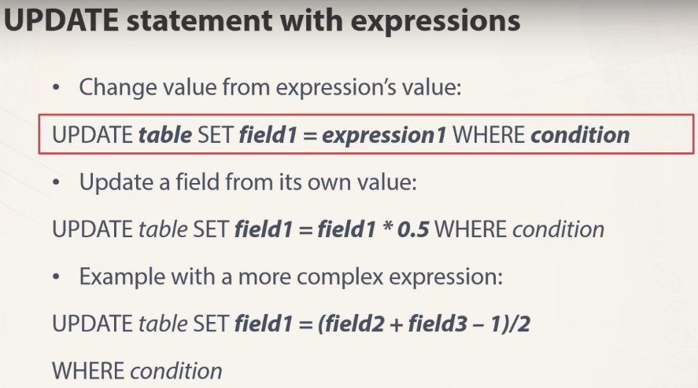

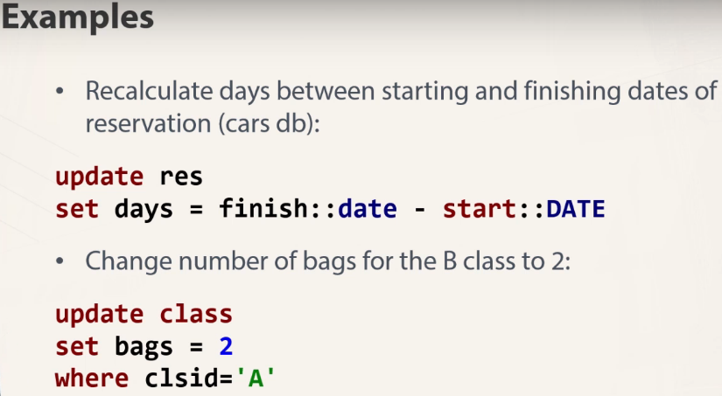

DELETE

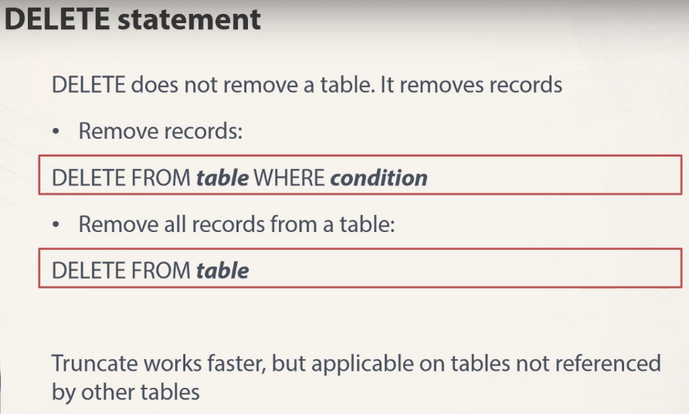
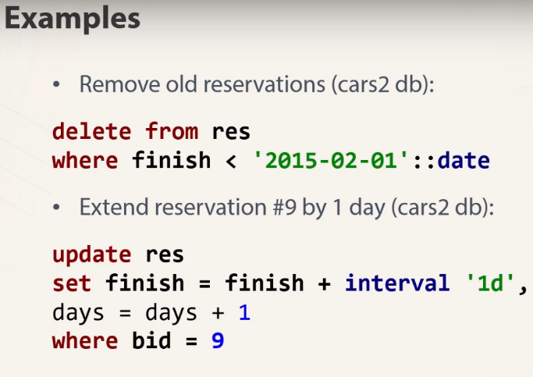

Data modifications based on subqueries and other tables

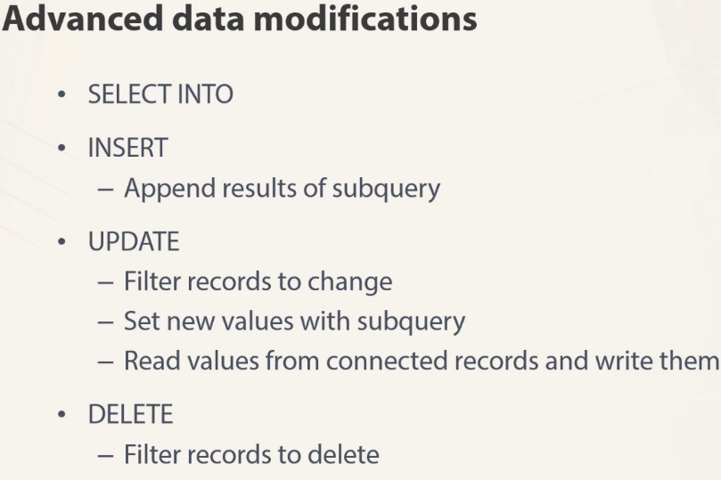

SELECT INTO

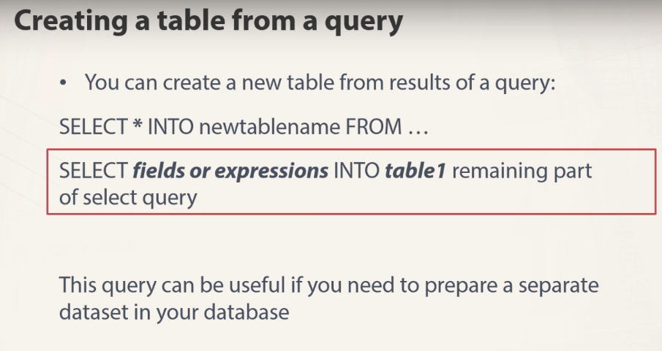

INSERT

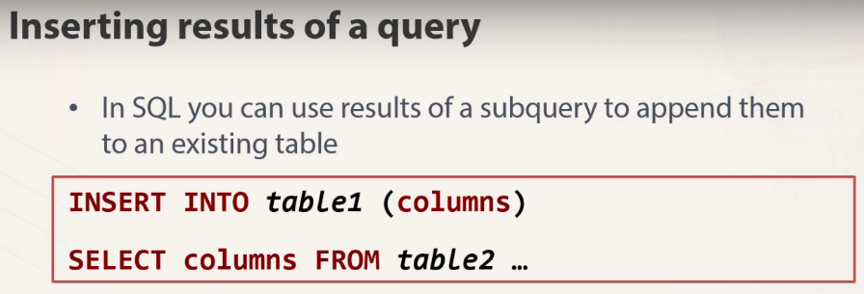

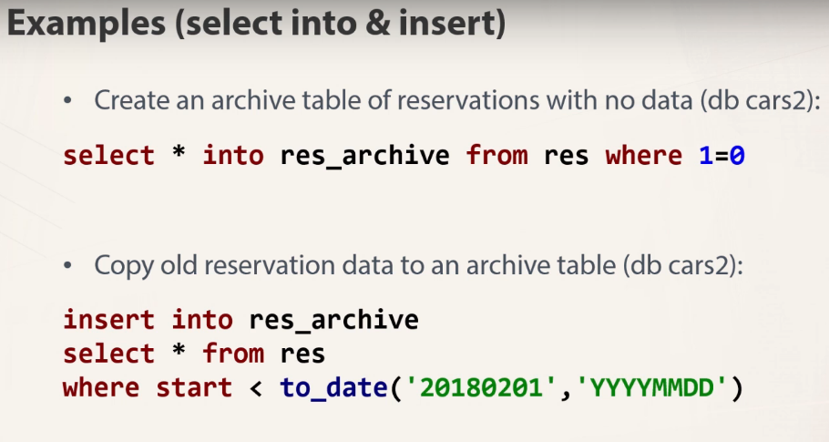

UPDATE

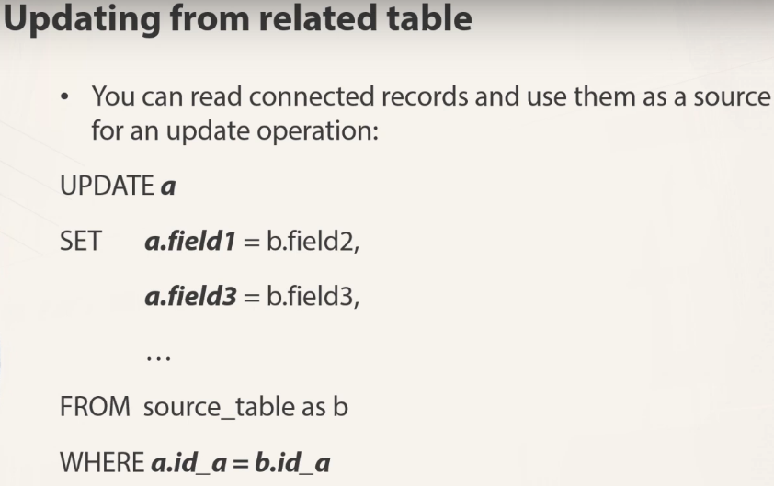
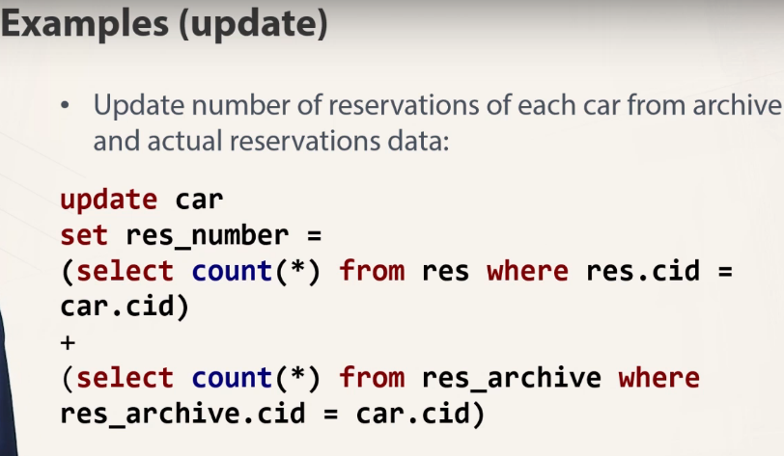

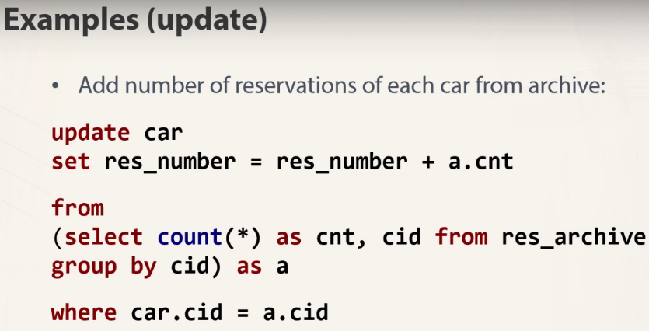

DELETE

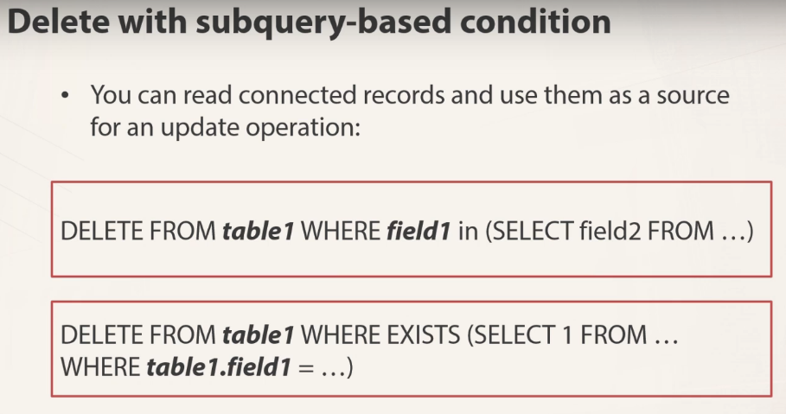
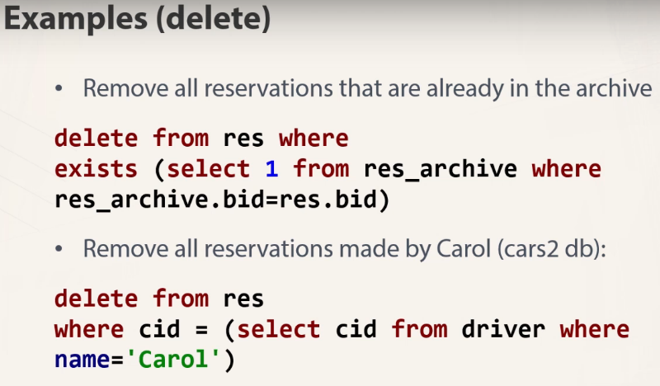

Working with users and roles
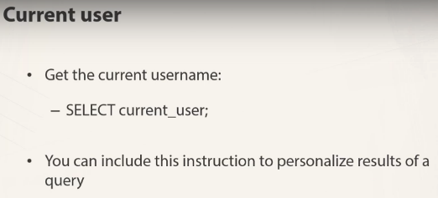

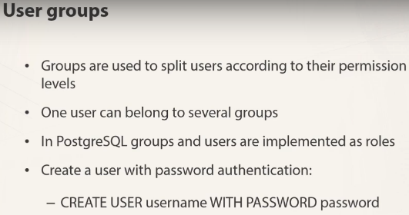

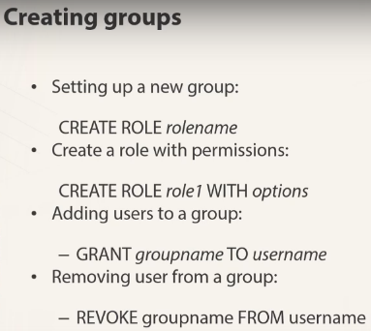

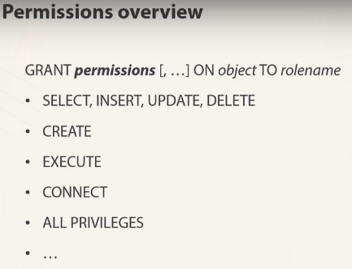

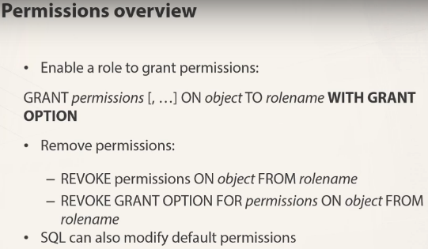

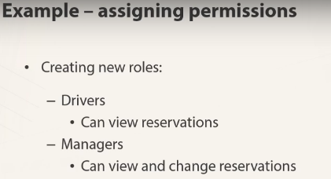

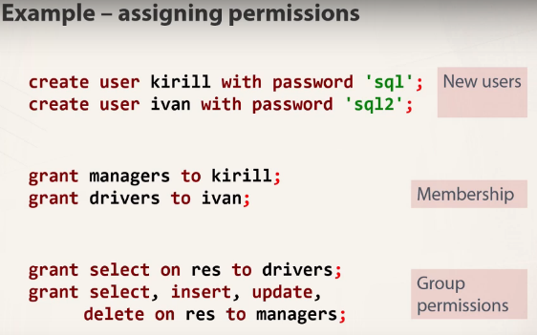

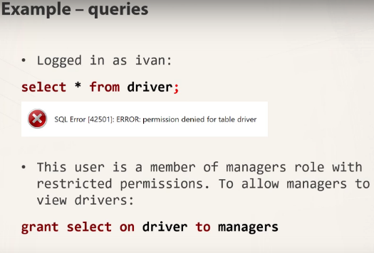

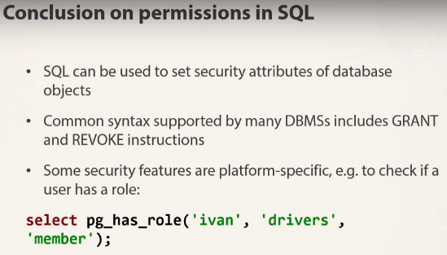

ALTER

Оператор ALTER TABLE обеспечивает возможность изменять структуру существующей таблицы. Например, можно добавлять или удалять столбцы, создавать или уничтожать индексы или переименовывать столбцы либо саму таблицу. Можно также изменять комментарий для таблицы и ее тип.



